1. Why Writing Songs Makes You Feel Better: Insights from Psychologists
Have you ever felt it? That suffocating weight in your chest after being wronged, like you can’t catch your breath. Or perhaps that nagging sense of unease when a story you loved ends on an ambiguous cliffhanger. Psychologists believe that the process of creating music provides a vital "sense of control." Real life rarely follows logic; no one truly has their hands on the wheel. In music, however, you decide every single note. The helplessness imposed by reality finds solace in rhythm and rhyme. This shift—from being a "victim" of circumstance to a "creator" of art—significantly alleviates anxiety and depression. Furthermore, watching a fleeting inspiration materialize into a finished work provides a powerful sense of accomplishment.
Traditionally, the barrier to entry for music production was incredibly high. To turn a mood into a song, you had to master music theory, navigate complex software like Cubase, or spend years practicing an instrument. Because inspiration is often ephemeral, these technical hurdles often drain a person's passion before the first note is even played. In the end, joy, sorrow, and deep reflection are often reduced to a numb, "ok......"
AI music tools like MakeBestMusic are closing this gap between technical skill and emotional expression. MakeBestMusic acts as an intelligent translator, turning your raw emotional materials into auditory art. It can organize emotional fragments into coherent lyrics and transform text into music via simple prompts. By simplifying creation into "intelligent text expansion," it empowers everyone to bypass technical limitations, record their own stories, and heal their hearts through music.
2. A Step-by-Step Guide: Turning Your Emotions into Song with MakeBestMusic
To make those intangible thoughts concrete, we need a streamlined approach. By following the MakeBestMusic workflow, you can "bottle" your current mood into a melody in just three steps.
Step 1: Use the AI Lyric Writer to Pen Your Thoughts
Many iconic songs begin with a compelling story. Relatable lyrics are often the starting point for classic works. For non-professionals, the challenge is often expanding fragmented, hard-to-describe feelings into lyrics that possess rhythm, poetry, and narrative flow.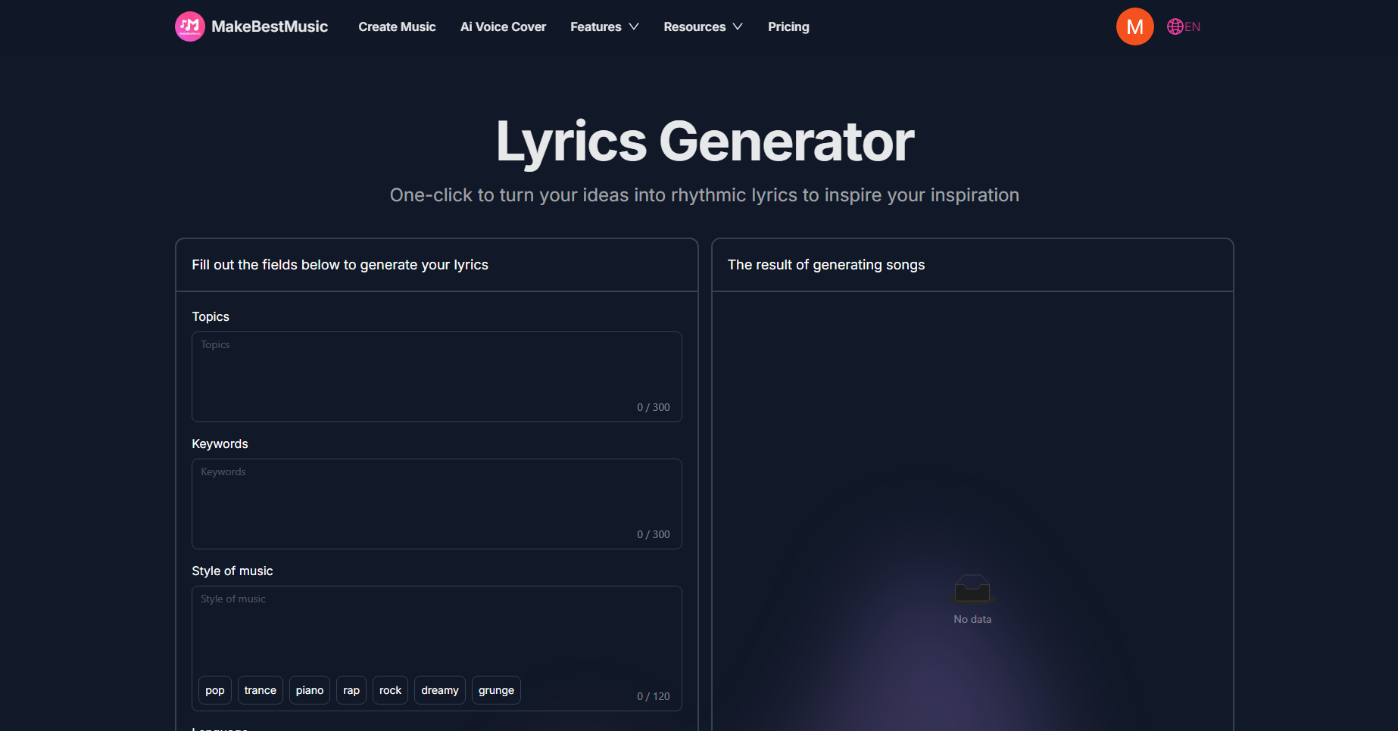
The built-in AI lyric writer in MakeBestMusic is designed specifically for this. Based on a simple description, it automatically completes structures like [Verse], [Chorus], and [Bridge]. This doesn't just turn your mood into flowing prose; these structural tags help the AI singer and the composition align perfectly.
- Log in to the MakeBestMusic official website. Click "Features" in the navigation bar and select "Lyrics Generator."
- In the Lyrics section, click the "Generate Lyrics" button.
- Fill in the theme, keywords, song style, and language. The AI will then generate lyrics based on your requirements.
The resulting lyrics retain your emotional themes and imagery while providing "structural anchors" for the music's ups and downs. This allows the audio generation system to accurately recognize emotional transitions. You no longer need to obsess over rhyming schemes; instead, you can focus on exploring and describing your feelings, resulting in an artistically and emotionally resonant draft in minutes.
Step 2: Choose the Right Style and Prompts
Once you have the "soul" of the song (the text), the next step is finding the right "vessel." MakeBestMusic allows users to use structured style prompts to describe arrangement needs. This ensures the generated music matches the required style, instrumentation, and structure.
Science and experience both show that the frequencies of different instrument combinations directly impact our endocrine levels and moods. By entering or tweaking the following structured prompts in the "Style" box, you can see this for yourself:
下面是具体操作流程：
- 首先，在首页选中并点击‘Create Music’，切换到“Custom”模式
- 在操作界面找到‘Styles’，输入下面的范例提示词，并在 Lyrics 文本框中输入歌词
- 最后，点击 Create 按钮，开始生成
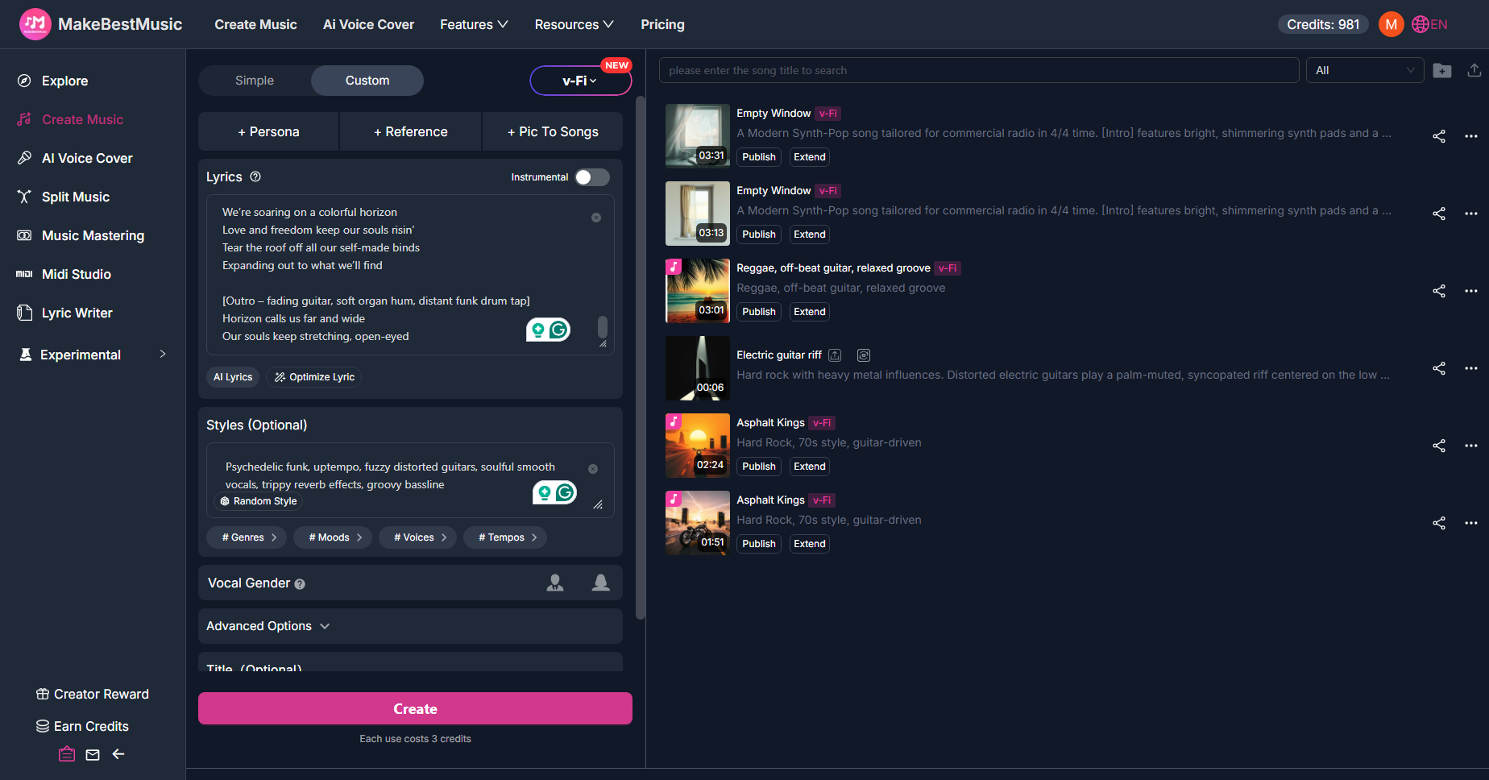
Joy requires high frequencies and a sense of "bounce." We suggest a combination of Funk Guitar and Slap Bass because their syncopated rhythms create a strong groove. The percussive nature of Slap Bass mimics the heartbeat of excitement, while crisp, clean guitars enhance auditory clarity, physiologically inducing a happy state.

Example Prompt for a Happy Song:

A vibrant Funk Pop song in G major, 4/4 time, 115 BPM.

[Intro]
Features a catchy slap bass riff and a bright, clean electric guitar melody.

[Verse 1] [Pre-Chorus 1]
The syncopated electric guitar plays rhythmic chords to support the upbeat vocals.

[Interlude]
Performed with a tight drum fill and a funky bass groove.

[Verse 2]
A crisp percussion section is added, providing a steady, danceable rhythm.

[Verse 3]
Additional synth layers and subtle background harmonies are introduced to build texture and fill the soundscape.

[Verse 4]
The arrangement's energy and volume increase as all instruments prepare for the transition.

[Instrumental Solo]
The electric guitar uses wah-wah effects and rapid riffs to build toward the climax, enhancing the positive intensity.

[Chorus]
Soulful vocal harmonies are layered, and the full groove kicks in, driving the music to its peak.

[Outro]
Concludes with a final funky guitar flourish and a tight drum hit.

- Adjusting for Other Emotions:
- Anger: Increase the tempo to over 140 BPM and use C Minor. Swap the bass for "heavy distorted guitar" and add "double-kick drums" to the rhythm section. This high-density distortion transforms destructive impulses into powerful Metal music.
- Sadness: Slow down significantly (e.g., 65 BPM) and use A Minor. Replace the guitar with a "soft solo piano" and add a "warm cello section" in the interlude. This shifts the focus from rhythm to melodic extension, giving your grief room to breathe.
- Anxiety: Keep a moderately fast tempo but add "repetitive electronic synth pulses" and "dissonant synth pads." These looping, slightly "off" frequencies mirror the restlessness of an anxious mind.
- Loneliness: Simplify the arrangement. Remove the "full groove" descriptions and opt for deep echoes of a single instrument, such as a "solitary acoustic guitar with long reverb." This creates a sense of aural isolation.
By acting as a "director" of instruments and modes, even non-musicians can achieve complex musical arrangements that resonate deeply with their inner state.
Step 3: Create Your Own "Emotional Cover" with AI Voice Cover
While AI voices are professional, a song feels more like a private journal when it uses your voice. To make a track truly personal, use the Voice Cover feature to inject your own "soul" into the recording.
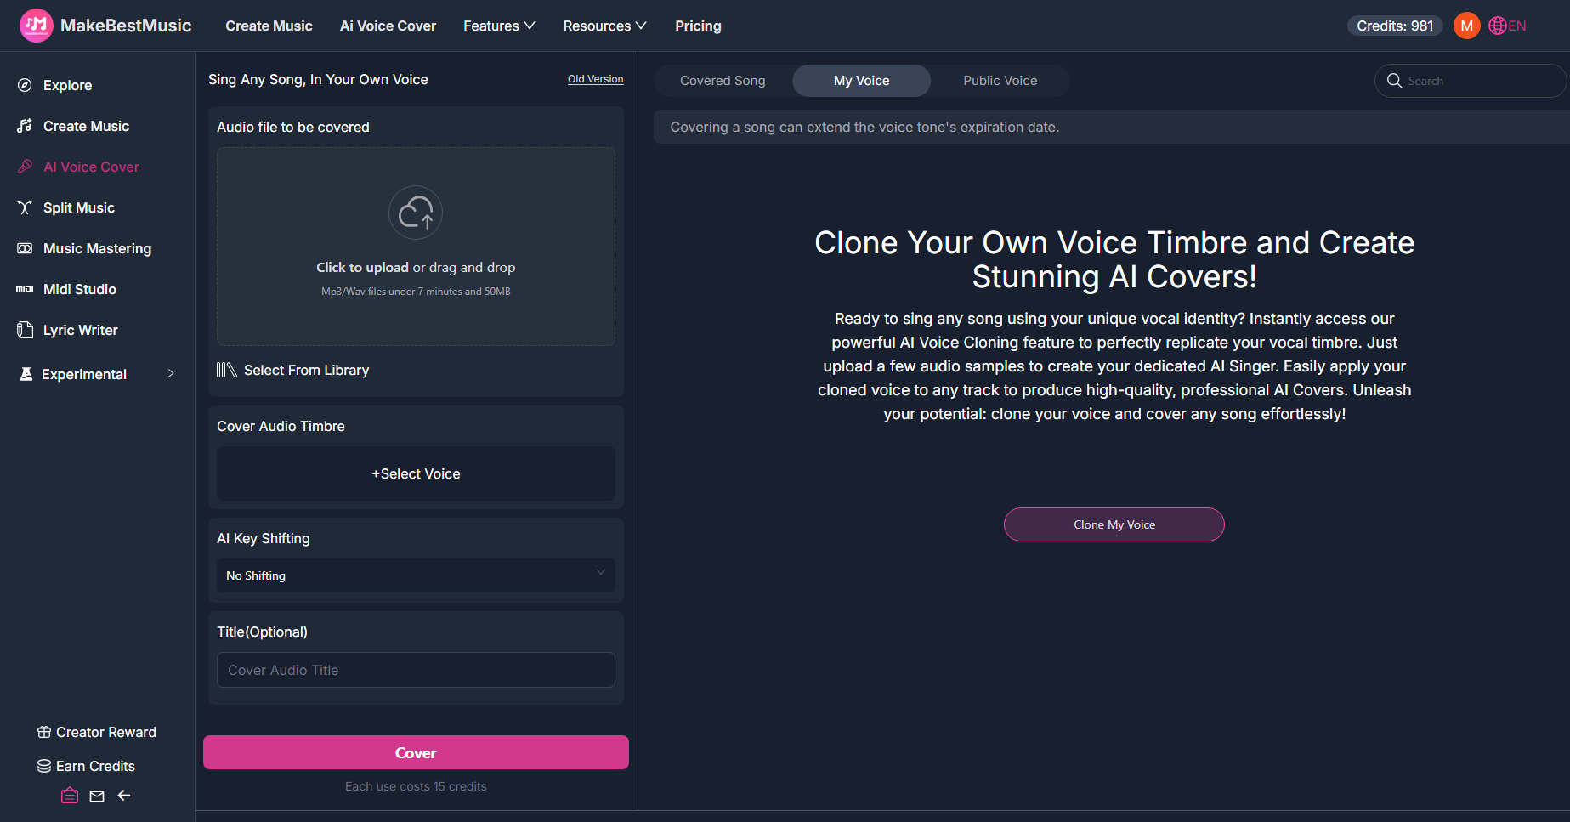
How to use AI Voice Cover :
- Go to the "Voice Cover" interface in the top navigation bar.
- Select "My Voice" then "Clone My Voice." Upload a 1-minute recording of yourself singing without background music (Dry Vocal). Ensure the audio is clear.
- Choose your generated track from the library to perform the "cover."
The system automatically extracts your vocal formants and breathing characteristics, blending your unique timbre into the song. The result sounds remarkably like you—even if you aren't a trained singer, the AI can help you navigate complex vocal performances. This creates a profound sense of satisfaction and allows your future self to look back and think, "Oh, so that’s exactly how I felt back then..."
3. A Song a Week: Building an Emotional Music Journal
Once you've mastered the process, why not start a long-term project? Create one song per week to document your current thoughts and inspirations. Name and export your tracks with dates and mood keywords, organizing them into folders.
In just a few months, you’ll have an audio emotional diary. Unlike text, music allows you to "re-live" your past emotions—whether it was anger, anxiety, or the joy of a wish fulfilled. This process helps you repair and regain control over your emotional state, fostering personal growth.
Listening back, you'll realize that the shifts in intensity, drum beats, and amplitude are direct reflections of your internal world. This record is more visceral than a diary and more evocative than a photo. Furthermore, since MakeBestMusic provides clear commercial licensing for subscribers, you can confidently share these records on streaming platforms, allowing your story to resonate with a wider audience.
4. Conclusion
In this era of fast-paced, fragmented information, we need an emotional outlet more than ever. We need a way to process serious, growth-oriented reflections that short-form entertainment simply can't provide. With MakeBestMusic’s intuitive interface and powerful generation capabilities, everyone has the chance to bridge the skill gap and freeze a moment of insight into a melody.
Log in to MakeBestMusic today, start your music diary, and let the world—and yourself—hear the deepest parts of your heart.

